**Final Summative Project – Tetris Game**

**TEJ3M**

**For**

**Mr. Laxton**

**By**

**Saahiti Annamneedi and Alisa Nikiforova**

**June 18, 2013**

'Saahiti and Alisa

'1. Tetris start page

Public Class Main

Private Sub btnInstructions_Click(ByVal sender As System.Object, ByVal e As System.EventArgs) Handles btnInstructions.Click

Instructions.Show()

Me.Hide()

End Sub

Private Sub btnPlay_Click(ByVal sender As System.Object, ByVal e As System.EventArgs) Handles btnPlay.Click

Game.Show()

Me.Hide()

End Sub

Private Sub Main_Load(ByVal sender As System.Object, ByVal e As System.EventArgs) Handles MyBase.Load

'My.Computer.Audio.Play("F:\00vb!\tetris theme.wav",AudioPlayMode.BackgroundLoop)

Dim MyProcess As New Process

MyProcess.StartInfo.FileName = "F:\00vb!\tetris theme.wav"

'MyProcess.StartInfo.WindowStyle = ProcessWindowStyle.Minimized

MyProcess.Start()

End Sub

End Class

'Saahiti and Alisa

'2. Tetris instructions page

Public Class Instructions

Private Sub Button1_Click(ByVal sender As System.Object, ByVal e As System.EventArgs) Handles btnPlay.Click

Game.Show()

Me.Hide()

End Sub

Private Sub Instructions_Load(ByVal sender As System.Object, ByVal e As System.EventArgs) Handles MyBase.Load

Dim c As Color = Color.FromArgb(236, 195, 30)

btnPlay.BackColor = c

End Sub

Private Sub Label10_Click(ByVal sender As System.Object, ByVal e As System.EventArgs) Handles Label10.Click

End Sub

End Class

'Saahiti and Alisa

'3. Tetris game code

Imports System.Timers

Public Class Game

Public time As Integer

Public time2 As Decimal

Public c As Color = Color.Crimson

Private Sub btnClear_Click(ByVal sender As System.Object, ByVal e As System.EventArgs) Handles btnClear.Click

Out(Val(888), 0)

End Sub

Private Sub Form1_KeyDown(ByVal sender As System.Object, ByVal e As System.Windows.Forms.KeyEventArgs) Handles MyBase.KeyDown

Dim bHandled As Boolean = True

Select Case e.KeyCode

Case Keys.NumPad1

Out(Val(888), 1)

time2 = 0

timer2.Start()

e.Handled = True

back_Color(lblA)

Case Keys.NumPad2

Out(Val(888), 2)

time2 = 0

timer2.Start()

e.Handled = True

back_Color(lblB)

Case Keys.Up

Out(Val(888), 4)

time2 = 0

timer2.Start()

e.Handled = True

back_Color(lblUp)

Case Keys.Right

Out(Val(888), 8)

time2 = 0

timer2.Start()

e.Handled = True

back_Color(lblRight)

Case Keys.Down

Out(Val(888), 16)

time2 = 0

timer2.Start()

e.Handled = True

back_Color(lblDown)

Case Keys.Left

Out(Val(888), 32)

time2 = 0

timer2.Start()

e.Handled = True

back_Color(lblLeft)

End Select

End Sub

Private Sub Form1_Load(ByVal sender As System.Object, ByVal e As System.EventArgs) Handles MyBase.Load

txtCommand.Focus()

Dim c As Color = Color.FromArgb(9, 116, 184)

'(2, 103, 171)

btnStart.BackColor = c

btnStop.BackColor = c

btnClear.BackColor = c

End Sub

Private Sub txtCommand_TextChanged(ByVal sender As System.Object, ByVal e As System.EventArgs) Handles txtCommand.TextChanged

If txtCommand.Text = "1" Then

Out(Val(888), 1)

txtCommand.Text = ""

time2 = 0

timer2.Start()

back_Color(lblA)

ElseIf txtCommand.Text = "2" Then

Out(Val(888), 2)

txtCommand.Text = ""

time2 = 0

timer2.Start()

back_Color(lblB)

ElseIf txtCommand.Text = "3" Then

Out(Val(888), 3)

txtCommand.Text = ""

time = 0

timer1.Start()

txtCommand.Text = ""

back_Color(lblA)

back_Color(lblB)

ElseIf txtCommand.Text = "w" Then

Out(Val(888), 4)

txtCommand.Text = ""

time2 = 0

timer2.Start()

back_Color(lblUp)

ElseIf txtCommand.Text = "d" Then

Out(Val(888), 8)

txtCommand.Text = ""

time2 = 0

timer2.Start()

back_Color(lblRight)

ElseIf txtCommand.Text = "s" Then

Out(Val(888), 16)

txtCommand.Text = ""

time2 = 0

timer2.Start()

back_Color(lblDown)

ElseIf txtCommand.Text = "a" Then

Out(Val(888), 32)

txtCommand.Text = ""

time2 = 0

timer2.Start()

back_Color(lblLeft)

Else

txtCommand.Text = ""

End If

End Sub

Private Sub btnStart_Click(ByVal sender As System.Object, ByVal e As System.EventArgs) Handles btnStart.Click

Out(Val(888), 3)

time = 0

timer1.Start()

End Sub

Private Sub btnStop_Click(ByVal sender As System.Object, ByVal e As System.EventArgs) Handles btnStop.Click

Out(Val(888), 3)

time = 0

timer1.Start()

End Sub

Private Sub timer1_Timer(ByVal sender As System.Object, ByVal e As System.EventArgs) Handles timer1.Tick

time += 1

If (time >= 5) Then

timer1.Stop()

time = 0

Out(Val(888), 0)

End If

backGround_White()

End Sub

Private Sub timer2_timer(ByVal sender As System.Object, ByVal e As System.EventArgs) Handles timer2.Tick

timer2.Stop()

Out(Val(888), 0)

time2 = 0

backGround_White()

End Sub

Private Sub lblUp_Click(ByVal sender As System.Object, ByVal e As System.EventArgs) Handles lblUp.Click

Out(Val(888), 4)

time2 = 0

timer2.Start()

back_Color(lblUp)

End Sub

Private Sub lblRight_Click(ByVal sender As System.Object, ByVal e As System.EventArgs) Handles lblRight.Click

Out(Val(888), 8)

time2 = 0

timer2.Start()

back_Color(lblRight)

End Sub

Private Sub lblDown_Click(ByVal sender As System.Object, ByVal e As System.EventArgs) Handles lblDown.Click

Out(Val(888), 16)

time2 = 0

timer2.Start()

back_Color(lblDown)

End Sub

Private Sub lblLeft_Click(ByVal sender As System.Object, ByVal e As System.EventArgs) Handles lblLeft.Click

Out(Val(888), 32)

time2 = 0

timer2.Start()

back_Color(lblLeft)

End Sub

Private Sub lblA_Click(ByVal sender As System.Object, ByVal e As System.EventArgs) Handles lblA.Click

Out(Val(888), 1)

time2 = 0

timer2.Start()

back_Color(lblA)

End Sub

Private Sub lblB_Click(ByVal sender As System.Object, ByVal e As System.EventArgs) Handles lblB.Click

Out(Val(888), 2)

time2 = 0

timer2.Start()

back_Color(lblB)

End Sub

Public Sub backGround_White()

lblA.BackColor = Color.Transparent

lblB.BackColor = Color.Transparent

lblUp.BackColor = Color.Transparent

lblRight.BackColor = Color.Transparent

lblDown.BackColor = Color.Transparent

lblLeft.BackColor = Color.Transparent

End Sub

Public Sub back_Color(ByVal sender As System.Object)

sender.backcolor = c

End Sub

Private Sub btnInstructions_Click(ByVal sender As System.Object, ByVal e As System.EventArgs) Handles btnInstructions.Click

Instructions.Show()

Me.Hide()

End Sub

End Class

'Saahiti and Alisa

'Module

Module Module1

Public Declare Function Inp Lib "inpout32.dll" Alias "Inp32" (ByVal PortAddress As Integer) As Integer

Public Declare Sub Out Lib "inpout32.dll" Alias "Out32" (ByVal PortAddress As Integer, ByVal Value As Integer)

End Module

**Screen shots of Tetris VB program while debugging**

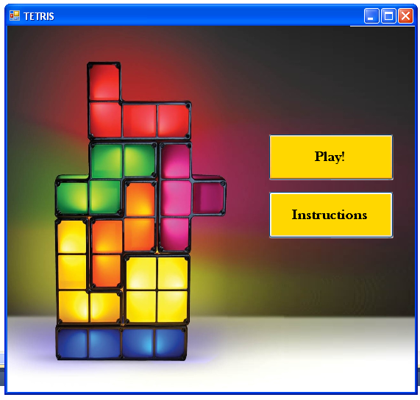

Figure 1: Start page

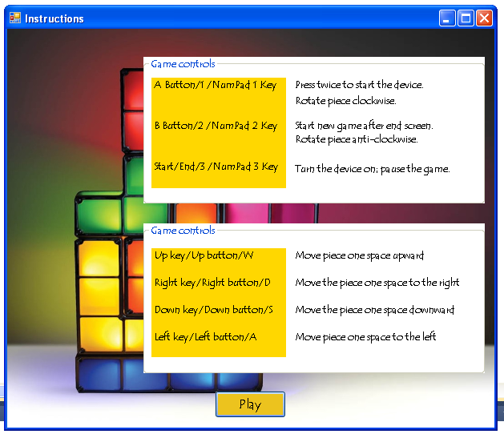

Figure 2: Instructions page

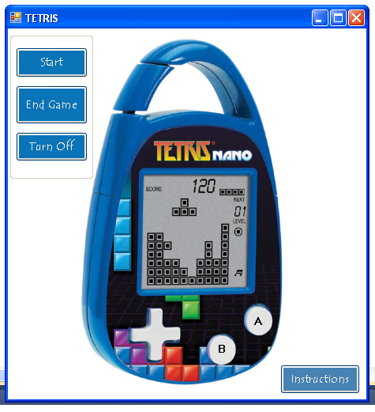

Figure 3: Game page